A special welcome this week to the boys and girls from St. Coen’s N.S. who should have made their Confirmation this week on Friday, June 12. We know that you will be disappointed that you won’t be able to make your Confirmation before the end of the schoolyear, but don’t worry we will be in touch with you when everything opens up again and when it is safe to do so. In the meantime, enjoy the beautiful summer weather and this special time with your families. Don’t forget if you would like to send us any of your work or to ask any questions you can get in touch with us by email at:
parishofficewicklow@gmail.com.

INTRODUCTION
This Sunday, June 14, we celebrate Corpus Christi. Corpus Christi means ‘Body of Christ’.
What would happen if we had no food or anything to drink? Together they keep us alive, and without their life-giving nourishment we would die. Jesus is the ‘bread of life’ who shares himself with us in a special way during the Mass.

GOSPEL (John 6:51-58)
Jesus said to the crowd: “I am the living bread that came down from heaven. Whoever eats this bread will live forever. This bread is my flesh, which I will give for the life of the world.”
Then the Jews began to argue sharply among themselves, “How can this man give us his flesh to eat?”
Jesus said to them, “Very truly I tell you, unless you eat the flesh of the Son of Man and drink his blood, you have no life in you. Whoever eats my flesh and drinks my blood has eternal life, and I will raise them up at the last day. For my flesh is real food and my blood is real drink. Whoever eats my flesh and drinks my blood remains in me, and I in them. Just as the living Father sent me and I live because of the Father, so the one who feeds on me will live because of me. This is the bread that came down from heaven. Your ancestors ate manna and died, but whoever eats this bread will live forever.”
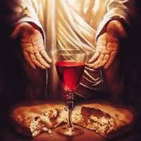

ABOUT THE GOSPEL
In today’s gospel, we again come into contact with Jesus as the bread of life. He says, “Those who eat my flesh and drink my blood abide in me, and I in them.” If we think of Jesus as the food and drink that nourish us and fill us, we might imagine what it is to have Jesus within us. A visual exploration of this idea is found in Elisa Kleven’s book, Sun Bread.
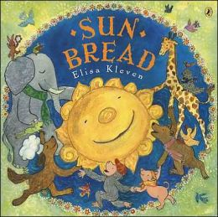
When the days are dark, cold, and dreary, a baker creates a loaf of bread to remind people of the sun. As they feast on the bread, they are filled with the sun’s light and warmth. Likewise, when we receive Jesus, the bread of life, we are filled with his light and life. Thanks be to God for that good news!
CORPUS CHRISTI
Think of the times when we would normally come together to celebrate a special occasion with a meal with family and friends. When we come to Mass, we come as one large family to celebrate something which happened for all of us – the resurrection of Jesus. We share a meal together just as Jesus did at the Last Supper.
What food and drink did Jesus share with his disciples that night? – Jesus shared a loaf of bread and a cup of wine. He changed the bread and wine into his own body and blood, to nourish them with his life-giving power. Just as our bodies need nourishment to live, so do our spiritual souls.
What happens when we celebrate the Mass together? – At our celebration of the Eucharist, which means ‘thanksgiving’, we remember the meal which Jesus shared with his friends the night before he died; and we share in his death and resurrection. We believe that through the power of God, the bread and wine become the body and blood of Jesus, who gives himself to each of us in a very special way. Jesus said, ‘I am the bread of life’, and when we share in the Eucharistic meal, we share life with the Son of God himself.

PRAYER
Lord Jesus,
You are the living bread
Which comes to each of us
In a special way.
Help me to share the joy of your love
With others I meet. Amen.

