Welcome to our Communion Religion pages for Sunday, June 7. This Sunday we celebrate Trinity Sunday. God shares himself with us through the three persons of the Trinity. We share the love of God the Father, the goodness of Jesus the Son, and the friendship of the Holy Spirit. A special welcome this week to the boys and girls from the de la Salle Communion religion class who should have been making their First Holy Communion this Sunday. We know that you are disappointed that it won’t be happening just yet, but we hope that you have a nice day and can celebrate with your family. Don’t forget that we will be in touch with you about your First Holy Communion when everything opens up again and when it is safe to do so. In the meantime, enjoy the beautiful summer weather and this special time with your families. Don’t forget if you would like to send us any of your work or to ask any questions you can get in touch with us by email at:
parishofficewicklow@gmail.com.

GOSPEL (John 3:16-18)
Jesus said to Nicodemus:
'God loved the world so much that he gave his only Son, so that everyone who believes in him may not be lost but may have eternal life.
'For God sent his Son into the world not to condemn the world, but in order that the world might be saved through him. Those who believe in him are not condemned; but those who do not believe are condemned already, because they have not believed in the name of the only Son of God.
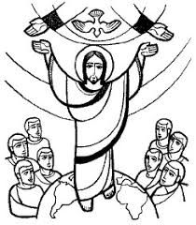
ABOUT THE GOSPEL
In today’s lesson, we’re learning about a conversation Jesus had with a guy named Nicodemus. Nicodemus was a Pharisee which means he was a smart Jewish guy who knew God’s law inside and out. He thought he knew everything he needed to know about God. He thought he was really good.
But Nicodemus heard that Jesus was teaching that we all have a sin problem that makes us not good people. So, he went to meet Jesus to ask him some questions. Jesus challenged Nicodemus by telling him that just knowing the law wouldn’t make him good enough for God. The only way to be good enough for God was by having a relationship with Jesus. Remember, Jesus is God, and he came to save us from our sin problem. So, it doesn’t matter how smart we think we are or how much we know about the Bible, if we haven’t trusted in Jesus, then our sins aren’t forgiven. This was an important lesson for Nicodemus to understand and it’s important for us, too. On our own, we can never be good enough for God. We need Jesus to forgive us and live in our hearts and help us to live for him.

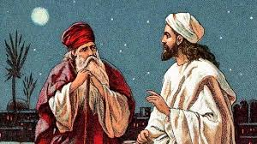
TRINITY SUNDAY
Sunday, June 7, is Trinity Sunday. Do you know what Trinity means and what we are celebrating today? – ‘Trinity’ means something made up of three, and today we give thanks for the three persons of God.
Who are the three persons who make up the Holy Trinity and what do you know about them?
- God the Father – He created the world and everything in it. He loves us all dearly and sent his only son, Jesus, to rescue us from our sins.
- God the Son – Jesus was made man. We know many stories which remind us of his kindness and goodness, and his love for all people. He taught us how we should live and the path to follow to find our way to Heaven. His love was so great, he died on the cross and rose from the dead to save us from sin.
- God the Holy Spirit – We have learned that the Spirit takes many forms, wind, fire or a dove. He is invisible but very powerful, and he fills us with God’s life and warms our hearts with the ‘fire’ of God’s love and courage.
So there are three persons but only one God. Do you find this difficult to understand? – The Trinity is a mystery which we cannot really understand, but because we know that God can do anything, we believe in this mystery. It is part of our faith.
Have you a dressing up box in your house? Imagine that a child tries on three different hats which are linked to certain occupations or jobs. We might say, ‘This is John, the soldier – this is John, the fireman – this is John, the garda.’
God is rather like the child with the three hats, he is only one God but according to what ‘job’ he is doing, and what ‘hat’ he is wearing, he can appear as the Father, Son or Holy Spirit.
Do you remember talking about the shamrock on St. Patrick’s Day? St. Patrick used a shamrock to explain the Trinity to people. The shamrock is one leaf but there are three parts to it.

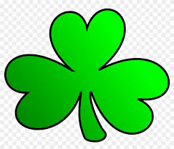

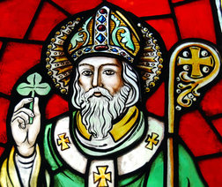

PRAYER
Glory be to the Father,
and to the Son,
and to the Holy Spirit:
As it was in the beginning,
is now,
and ever shall be,
world without end.
Amen.
A picture for you to colour:

